Batch: B2 Roll No.: 16010121200

Experiment / assignment / tutorial No. 4

Grade: AA / AB / BB / BC / CC / CD /DD

Signature of the Staff In-charge with date

Experiment No.:4

TITLE: Implementation of CRC & Checksum for Computer Networks
______________________________________________________________________________
AIM: To implement Layer 2 Error Control schemes: CRC & Checksum.
______________________________________________________________________________
Expected Outcome of Experiment:
CO:
______________________________________________________________________________
Books/ Journals/ Websites referred:
- A. S. Tanenbaum, “Computer Networks”, Pearson Education, Fourth Edition
- B. A. Forouzan, “Data Communications and Networking”, TMH, Fourth Edition
______________________________________________________________________________
Pre Lab/ Prior Concepts:
Data Link Layer, Error Correction/Detection, Types of Errors
___________________________________________________________________
New Concepts to be learned: Checksum.
___________________________________________________________________

CRC(Cyclic Redundancy Check):
Cyclic Redundancy Check (CRC) is another error detection technique to detect errors in data that has been transmitted on a communications link. A sending device applies a 16 or 32 bit polynomial to a block of data that is to be transmitted and appends the resulting cyclic redundancy check (CRC) to the block. The receiving end applies the same polynomial to the data and compares its result with the result appended by the sender. If they agree, the data has been received successfully. If not, the sender can be notified to resend the block of data.

At Sender Side:
- Sender has a generator G(x) polynomial.
- Sender appends (n-1) zero bits to the data.
Where, n= no of bits in generator
- Dividend appends the data with generator G(x) using modulo 2 division (arithmetic).
- Remainder of (n-1) bits will be CRC.

Codeword: It is combined form of Data bits and CRC bits i.e. Codeword = Data bits + CRC bits.

Example
Assume that –
(a) data is 10110.
(b) code generator is 1101.
(Code generator can also be mentioned in polynomial : x³+x²+1 )

Calculate CRC Bits: While calculating the CRC bits, we pad (n-1) 0’s to the message bits, where ‘n’ = no of bits in the code generator.

Cyclic Redundancy check will be generated as shown below –
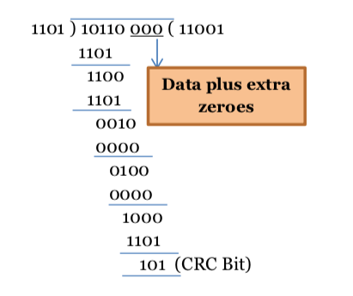
Figure 1: CRC calculation by sender

At Receiver Side
- Receiver has same generator G(x).
- Receiver divides received data (data + CRC) with generator.
- If remainder is zero, data is correctly received.
- Else, there is error.

Example
Assume the received message is 10110110.

Calculate CRC Bits: It does not add any padding bits, rather calculates from the entire received code word.

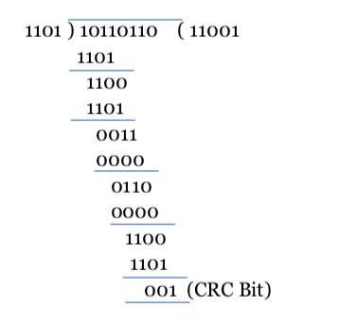
Figure 2: CRC calculation by receiver
The CRC bits are calculated to be different. Thus, there is an error detected.

Internet Checksum :
A checksum is a simple type of redundancy check that is used to detect errors in data.
Errors frequently occur in data when it is written to a disk, transmitted across a network or otherwise manipulated. The errors are typically very small, for example, a single incorrect bit, but even such small errors can greatly affect the quality of data, and even make it useless.
In its simplest form, a checksum is created by calculating the binary values in a packet or other block of data using some algorithm and storing the results with the data. When the data is retrieved from memory or received at the other end of a network, a new checksum is calculated and compared with the existing checksum. A non-match indicates an error; a match does not necessarily mean the absence of errors, but only that the simple algorithm was not able to detect any.

Simple Checksum:

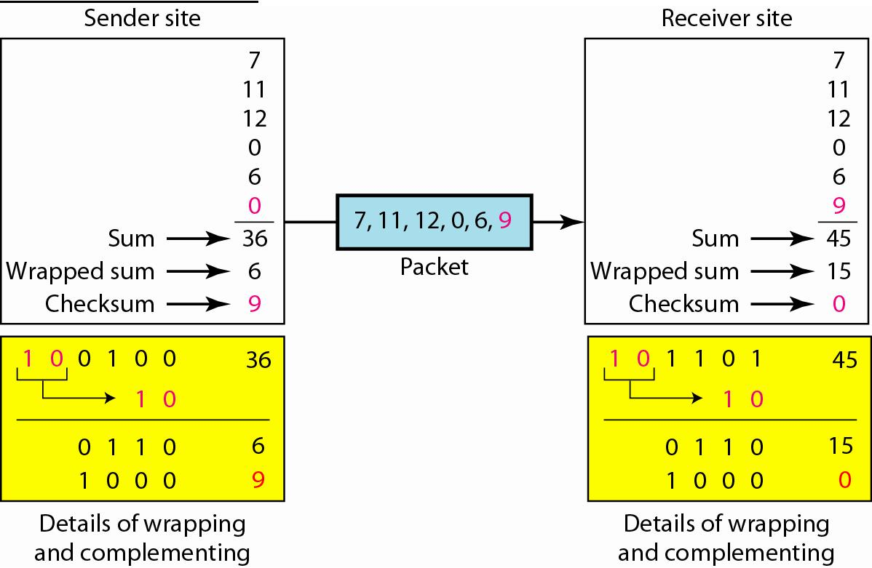

Internet Checksum
The following process generates Internet Checksum

Assume the packet header is: 01 00 F2 03 F4 F5 F6 F7 00 00
(00 00 is the checksum to be calculated)

The first step is to form 16-bit words.
0100 F203 F4F5 F6F7

The second step is to calculate the sum using 32-bits.
0100 + F203 + F4F5 + F6F7 = 0002 DEEF

The third step is to add the carries (0002) to the 16-bit sum.
DEEF + 0002 = DEF1

The fourth step is to take the complement. (1s becomes 0s and 0s become 1s)
~DEF1 = 210E

So the checksum is 21 0E.

The packet header is sent as: 01 00 F2 03 F4 F5 F6 F7 21 0E

* At the receiver, the steps are repeated.

The first step is to form 16-bit words.
0100 F203 F4F5 F6F7 210E

The second step is to calculate the sum using 32-bits.
0100 + F203 + F4F5 + F6F7 + 210E = 0002 FFFD

The third step is to add the carries (0002) to the 16-bit sum.
FFFD + 0002 = FFFF which means that no error was detected.

(In 1s complement, zero is 0000 or FFFF.)

Example:
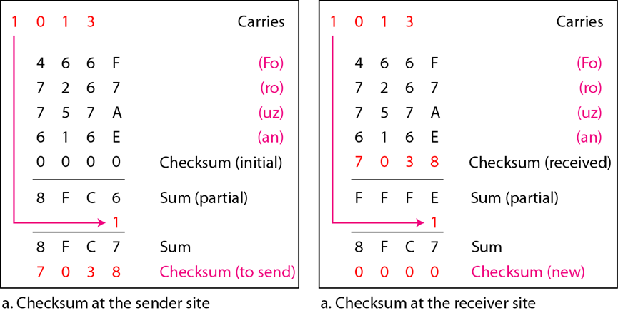

IMPLEMENTATION: (printout of codes)
CRC Algorithm:
Code:
def XOR(num1, num2):
xor = []
i = 0
for digit in num1:
if num2[i] == digit:
xor.append("0")
else:
xor.append("1")
i += 1
result = "".join(xor)
return result

def mod2div(data, generator):
gen_len = len(generator)
div = data[0:(gen_len)]
i = 0
while True:
nextBit = i + gen_len
if div[0] == '1':
div = XOR(div, generator)
else:
div = XOR(div, "0" * gen_len)
if nextBit < len(data):
div += data[nextBit]
div = div[1:]
else:
break
i += 1
crc = div[1:]
return crc

def sender(data, generator):
print("\nData to be sent:", data)
gen_len = len(generator)
padded_data = data + "0" * (gen_len - 1)
crc = mod2div(padded_data, generator)
print("Calculated CRC:", crc)
encrypted_data = data + crc
print("Encrypted data: ", encrypted_data)
return

def receiver(data, generator):
print("Received data:", data)
calculated_crc = mod2div(data, generator)
print("Calculated CRC:", calculated_crc)
if int(calculated_crc) == 0:
print("No error")
decrypted_data = data[:-3]
else:
print("Error detected")
decrypted_data = "Error"
return decrypted_data

data = input("Enter data to be sent: ")
codeGenerator = input("Enter Code Generator: ")
crc = sender(data, codeGenerator)
recd_data = input("\nEnter received data: ")
decrypted_data = receiver(recd_data, codeGenerator, crc)
print("Decrypted data:", decrypted_data)

Output:
When error is present:
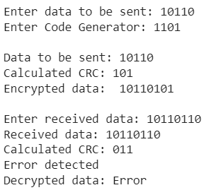
When error is absent:
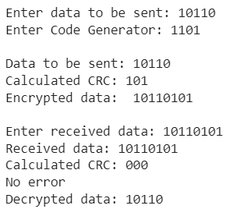

Checksum Algorithm:

CONCLUSION:
Successfully implemented CRC and Checksum Algorithm.
Post Lab Questions

- Discuss about the rules for choosing a CRC generator.
  - It should have at least two terms.
  - The coefficient of the term x0 should be 1.
  - It should not be divisible by x.
  - It should be divisible by x+ 1.
  - There are several different standard polynomials used by popular protocols for CRC generation.
- State the advantages and disadvantages of Internet Checksum.
Advantage:
The checksum detects all the errors involving an odd number of bits as well as
the error involving an even number of bits.

Disadvantage:
The main problem is that the error goes undetected if one or more bits of a subunit is damaged and the corresponding bit or bits of a subunit are damaged and the corresponding bit or bits of opposite value in second subunit are also damaged. This is because the sum of those columns remains unchanged.

Date: ___________ Signature of Faculty In-charge

